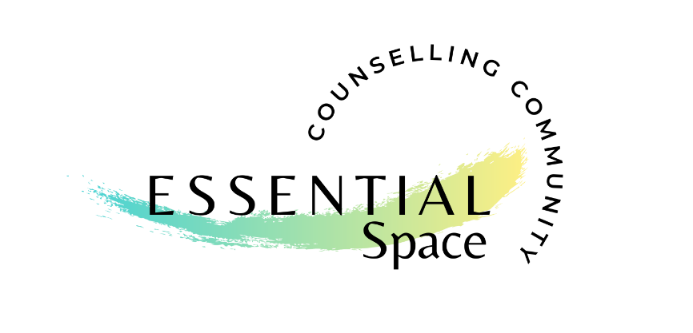
Statement of use
Risk of Coronavirus (COVID-19) Transmission at Essential Space

The Government published a statement confirming that it is lawful for our practice to be open.
Essential Space has conducted a thorough risk assessment to ensure adequate levels of safety in our building are implemented and maintained. We are following Government and Public Health England guidance and put in place hand sanitation, and protocols to protect our visitors and members. Despite these precautions, there is still a level of risk for transmission of the Coronavirus (COVID-19) and it is important that you understand the risk before you visit or use the building.
Precautions that Essential Space has in place:
- Essential Space operates using an appointment only rental service.
- Practitioners are required to keep a record of who has visited the building, and to clearly establish whether Coronavirus symptoms are present, if anyone in their household has symptoms or they have been in contact with anyone with COVID-19 symptoms before they attend the appointment.
- We enforce a policy that anyone with any COVID-19 symptoms must stay away from the building.
- A strict cleaning protocol is adhered to – please ask if you would like to know further information.
- All users should adhere to the social distancing guidance issued by the Government.
- The layout of the building has been adapted to maintain social distancing where possible.
- Families and groups are permitted providing it is for mental health or work reasons, they must not wait inside the building, and are restricted at this present time to socially distance once inside the building where possible, unless they are in a support bubble then this does not apply.
- Where possible open windows to allow fresh air to flow through the building
- Hand sanitation is provided at the entrance of the building, and additional sanitation is in each room.
- Antibacterial wipes are in each room and guidelines stipulate wiping down surfaces used between clients attending appointments.
- The bathroom and kitchen areas are permitted to two people at any one time using the facilities.
- It is advised that clients bring their own drink, and small groups held in the larger space with social distancing use disposable cups supplied and disposed of by the practitioner leading the group.
- All rubbish is disposed of after each appointment into the main outside bin.

Updated May 2021
Essential Space is committed to ensuring that measures are in place to minimise the risk of exposure to COVID-19, we cannot guarantee there is absolutely no risk to you as a result of attending or using our space.
People can catch COVID-19 from others who have the virus. The disease can spread from person to person through small droplets from the nose or mouth which are spread when a person with COVID-19 coughs or exhales. These droplets land on objects and surfaces around the person. Other people then catch COVID-19 by touching these objects or surfaces, then touching their eyes, nose or mouth. People can also catch COVID-19 if they breathe in droplets from a person with COVID-19 who coughs out or exhales droplets.
The risk of catching COVID-19 from someone with no symptoms at all is very low. However, many people with COVID-19 experience only mild symptoms. This is particularly true at the early stages of the disease. It is therefore possible to catch COVID-19 from someone who has, for example, just a mild cough and does not feel ill. (World Health Organisation)

Eligibility for using Essential Space
We are unable to offer face-to-face appointments to the following people:
If you are self-isolating - until your isolation period is over and you have no symptoms
If you have COVID-19 symptoms (whether diagnosed by test or not)
If you are living with someone with COVID-19 symptoms (whether diagnosed by test or not)
You have been in contact with anyone with suspected or confirmed COVID-19 and have been asked to self-isolate for 14 days by the Contact Tracing Service.
Practitioners please sign below:
- I am eligible to practice from Essential Space using the guidelines above, and have communicated any potential exposure to Coronavirus (COVID-19) truthfully.
- I understand that there is a potential risk of transmission of Coronavirus (COVID-19) as a result of using the building.
- I have read, agreed to and understood the statement above relating to Coronavirus (COVID-19) risk and agree to ensure my clients are also aware of this risk and have consented to receiving support/treatment.
- I understand that I, as an individual practitioner are personally responsible for client care and are expected to follow health and safety guidelines, minimising risk to myself, and others using the space.
Name: _________________________________________

Signature: _________________________________________

Date: _________________________________________
(Please retain a copy for yourself and send back a signed copy to SJ by email, thank you for continuing to use our practice)

